

**DATABASE MANAGEMENT SYSTEM**

**GROUP ASSIGNMENT**

**Course code:** (112023-LCP)

**Intake code:** UCDF2307ICT(SE)

**Lecturer: Ms. Lai Chew Peng**

|  |  |
| --- | --- |
| **Group Members** | **Student TP no.** |
| Denesh A/L Sellasamy | TP076723 |
| Chan Zyanne | TP075156 |
| Ang Jianming | TP076671 |
| Shim Yong Lin | TP076209 |

Table of Contents

1.0 Database and Database Management System 3

1.1 Disadvantages of File-based system 4

1.2 Advantages and functions of Database Management system 6

2.0 Business rules and Normalisation 8

2.1 List of Business Rules 8

2.2 Normalization 9

3.0 Entity Relationship Diagram 13

References 14

​​

​

​

​

​

​

​

​​

# 1.0 Database and Database Management System

A database and database management system are known as structured software that stores, organizes, and collects data and information. Companies and universities like APU that have a cafeteria with a high personnel count are required to manage a canteen by automatic procedures.

One reason for that is this system operates on paper and cash where customers must stay for the adjustment and pay the precise amount, which makes the payment and procedure time-consuming as they have to wait for change, and it is unconventional towards people that hate to carry coins (Kim, 2021; Menewar et al, 2023). However, the power of a database management system which is a much more convenient option compared to carrying cash, will most definitely help with the speed of payment ​(Kim, 2021)​. Which intent leads to a more automatic procedure with lesser time and energy being used while providing a more efficient way of payment.

Not only payment but also other useful functionalities that are based on several variables, including sales, items, stocks, employees, order cart, and many more that handle the canteen’s data as well as that of the students, staff, and patrons. Editing, adding, and changing records will be the means of carrying out proper resource or stock management of data integration of every sales record. These kinds of facilities can be found in various cafeterias, colleges, universities, schools, and businesses (Menewar et al, 2023) . Moving on, APU’s cafeteria is the most crowded area in the entire university where people eat, chat, discuss and make friends. Every weekday, at noon many students, lecturers, and people in general tend to be at the cafeteria ordering, buying, and lining up to get their food. Hence why having a good system is very important​ (Aberdeen, 2020)​.

In this assignment, we are going to give a rough understanding of why APU uses a database management system instead of a file-based system and we are also going to break down the potential structure of the database system being used in APU. Using the Crow’s foot notation, we can design an ideology of how the system works as well as the Structure Query Language of how it processes in codes. We might also potentially make it better than the original.

### 1.1 Disadvantages of File-based system

The term file-based system is a way to save data in a file format on a computer, smartphone, hard drive, or other storage device ​(Cambridge, 2024)​. Information is being kept separately in the files within the file system. These files are not linked to one another and can have varying formats and structures. Therefore, certain drawbacks could result from this, including data redundancy, data isolation, data sharing restrictions, and security problems.

Data Redundancy

The first issue faced by file systems is data redundancy. Data redundancy often occurs in file systems because each file isn’t linked together therefore the same data and information may be stored in duplicates ​(Singh, 2022)​. For example, in a scenario where the students and lecturers wish to order online, the food order file must be forwarded to the manager after the user’s order has finished. The manager then must gather the orders and forward the file to the assigned chef. In this situation, the same file has been duplicated more than once which causes the redundancy of data. Multiple data in the same storage not only wastes storage space but also causes higher maintenance fees and time ​(GeeksforGeeks, 2023)​.

Data Isolation

Data isolation in a file-based system implies the idea of keeping data distinct and independent of other data in the system ​(Wang, Wang, & Xue, 2021)​. Usually, data in a file-based system is arranged into distinct files or records ​(Sullivan & O'Brien, 2024)​. Data isolation may result from this when redundant or inconsistent data is contained in separate files. For instance, if several users or programs require access to the same data, they can keep separate copies of the information, which could result in data isolation.

Data Sharing Restrictions

File-based solutions might not have the tools necessary for effective data sharing and teamwork. It could be difficult to manage access and maintain data integrity when several users or programs require simultaneous access to the same data ​(Singh, 2022)​. Therefore, it is impossible to share data in real-time as it takes time to retrieve and forward the data. There may also be a need for file locks and manual synchronization techniques, which could cause delays and conflicts. In the case of an e-bookstore for instance, it can be challenging to pull together details about a book from one file and its availability from another, making it more difficult to get a whole picture ​(Bieri, 2021)​.

Security Problems

File-based systems often face security challenges. Data is stored in files, consequently, it can be vulnerable to unauthorized access, tampering, or loss. File permissions and access controls may be limited, making it difficult to enforce data security policies. Additionally, backup and recovery processes may be more complex and error-prone, increasing the risk of data loss or corruption. Different users may need to have access to data in different ways in certain circumstances. A data entry operator, for example, ought to be limited to entering data. The organization's chairman needs to have full access to and control over the data. File processing systems do not offer these kinds of security features.

### 1.2 Advantages and functions of Database Management system

Although there are many benefits to adopting a database management system, we will only be discussing the main advantages, including data recovery, data security, minimize data inconsistency and data privacy.

Data Recovery

The main benefit of a database and database management system is data recovery. Its techniques are provided by a Database Management System (DBMS). It helps to prevent data loss due to unanticipated occurrences, human mistakes, or system faults. The process comes from making cloud share of data, keeping it safe from theft or damage, and then retrieving the data to either the original location or a secure backup to continue operations (Aberdeen et al, 2020). To guard against changes like ransomware, this backup copy often ideally be fixed, meaning it cannot be changed after it is made. A subset of onsite and cloud-based technology solutions called backup and recovery also automates and supports this procedure, allowing businesses to preserve and secure their data for legal and commercial purposes.

Data Security

Another benefit of using DBMS is data security. The security measures are to regulate database access. A variety of guidelines, precautions, and methods are used in database security to safeguard the availability, confidentiality, and integrity of data kept in databases. It offers encryption, user authentication, and authorization which all work together to prevent illegal access to sensitive or private data (Aberdeen et al, 2020). Understanding the basic ideas and jargon related to database security is essential to putting in place efficient security measures.  By confirming users' identities, authentication makes sure that only people with permission can access the database ​(Omotunde & Ahmed, 2023)​.  Tokens, biometrics, multi-factor authentication, and passwords are examples of common authentication techniques ​(Wang, Wang, & Xue, 2021)​. This notion covers each aspect of information securely, including software programs, files and physical security of hardware and storage devices. Organizational policies and procedures are also included.

Minimise Data Inconsistency

When more than two tables in a database use the same data but get it from separate sources, is known as data inconsistency ​(Livshits, et al., 2021)​. Data inconsistency normally take place between different versions of the same data file, which appear in other places ​(Livshits, et al., 2021)​. Fortunately for DBMS, if the database is properly designed, the restrictions can be removed. So, there should be less inconsistency in data. In other cases, there should be more stability and no leaks or leaps in response to slight modifications in the database. In addition, it functions by minimizing data that are isolated and files that have repeated data.

Data Privacy

In most cases of DBMS, there is data privacy which is a must as it helps to protect personal information ​(Omotunde & Ahmed, 2023)​. Data privacy is the safeguard against unauthorised data being leaked ​(Omotunde & Ahmed, 2023)​. To give an idea of data privacy in DBMS, if customers hold records of purchasing an item for example, will have data that is stored in a structure and the structure influences how it is going to be accessed. Hence, its only purpose is to help users access their personal information without revealing any sensitive information to others.

# 2.0 Business rules and Normalisation

### 2.1 **List of Business Rules**

1. Only student or staff can register as MEMBER and place food orders from MENU.
2. Customers must register as MEMBER to access the menu, place orders, and provide ratings in a scale of 1 to 5.
3. A MEMBER can view the MENU, add food items to the ORDER, and make a payment.
4. The MEMBER’S contact information (email and contact number) is mandatory for payment confirmation and delivery.
5. A MEMBER can have zero, one or many ORDERS, ORDER is made by one MEMBER.
6. An ORDER is officially placed only when the MEMBER completes the payment. A payment is associated with just one ORDER. The order placed time is recorded.
7. The CHEF cooks the meal. The time is recorded after the cooking process is completed.
8. All ORDERS are managed by one MANAGER, three CHEFS, and three DISPATCH WORKERS.
9. The MANAGER will record details of the meal orders and cooked meal.
10. DISPATCH WORKERS must deliver cooked meals to MEMBERS within 15 minutes. The delivery status is recorded.
11. A MEMBER can provide only one rating and feedback for each food item on the MENU after the food is served.
12. The system notifies the MANAGER when a new ORDER is placed.
13. The MANAGER can view a summary report of daily sales and popular food items.

### 2.2 Normalization

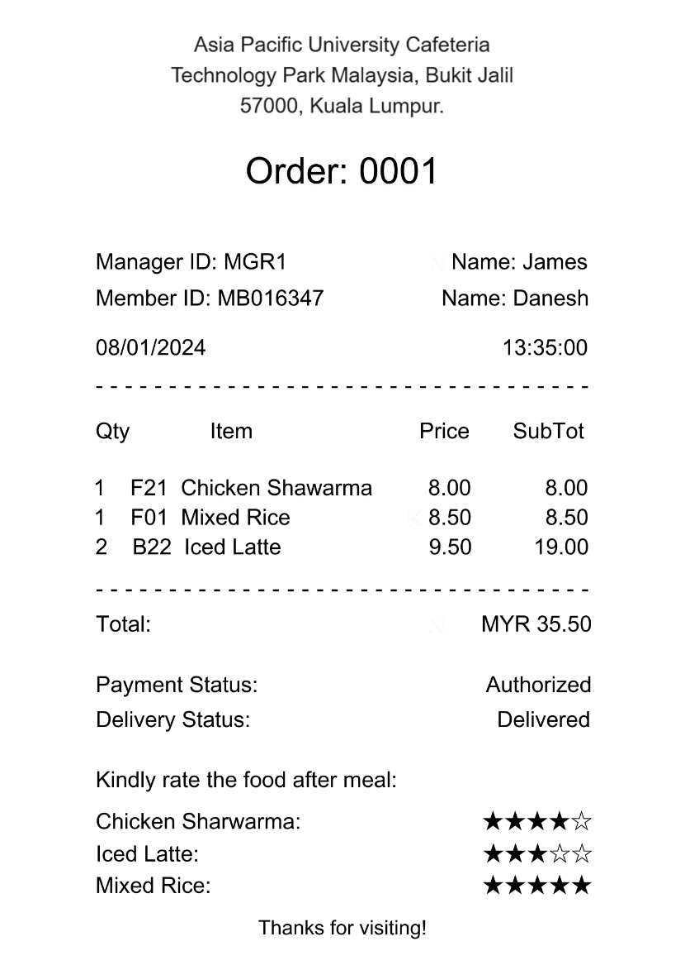Unnormalized Form (UNF)

First Normalized Form (1NF)

|  |  |  |  |  |  |  |  |  |  |  |  |  |  |  |  |
| --- | --- | --- | --- | --- | --- | --- | --- | --- | --- | --- | --- | --- | --- | --- | --- |
| OrderID | ManagerID | ManagerName | MemberID | MemberName | Date | Time | FoodID | FoodName | Qty | Price | SubTot | Total | PaymentStatus | DeliveryStatus | Rating |
| 0001 | MGR1 | James | MB016347 | Danesh | 08/01/2024 | 13:35:00 | F23 | Chicken Shawarma | 1 | 8.00 | 8.00 | 35.50 | Authorized | Delivered | 4 |
| 0001 | MGR1 | James | MB016347 | Danesh | 08/01/2024 | 13:35:00 | B22 | Iced Latte | 2 | 9.50 | 19.00 | 35.50 | Authorized | Delivered | 3 |
| 0001 | MGR1 | James | MB016347 | Danesh | 08/01/2024 | 13:35:00 | F01 | Mixed Rice | 1 | 8.50 | 8.50 | 35.50 | Authorized | Delivered | 5 |

Identified Primary Key: OrderID, ManagerID, MemberID, FoodID

There are partial dependencies in this table. Therefore, 2NF is needed to remove the dependencies.

Second Normalized Form (2NF)

Manager Menu

|  |  |
| --- | --- |
| ManagerID (PK) | ManagerName |
| MGR1 | James |

|  |  |  |
| --- | --- | --- |
| FoodID (PK) | FoodName | Price |
| F01 | Mixed Rice | MYR 8.50 |
| F23 | Chicken Shawarma | MYR 8.00 |
| B22 | Iced Latte | MYR 9.50 |

Member

|  |  |
| --- | --- |
| MemberID (PK) | MemberName |
| MB016347 | Danesh |

Order

|  |  |  |  |  |  |  |  |
| --- | --- | --- | --- | --- | --- | --- | --- |
| OrderID (PK) | ManagerID | MemberID | Date | Time | Total | PaymentStatus | DeliveryStatus |
| 0001 | MGR1 | MB016347 | 08/01/2024 | 13:35:00 | 35.50 | Authorized | Delivered |

OrderDetails Rating

|  |  |  |  |
| --- | --- | --- | --- |
| OrderID (PK) | FoodID | Qty | SubTot |
| 0001 | F01 | 1 | 8.50 |
| 0001 | F23 | 1 | 8.00 |
| 0001 | B22 | 2 | 9.50 |

|  |  |  |
| --- | --- | --- |
| FoodID (PK) | MemberID | Rating |
| F01 | MB016347 | 5 |
| F23 | MB016347 | 4 |
| B22 | MB016347 | 3 |

5 tables “Manager”, “Menu”, “Member”, “Order”, “OrderDetails”, and “Rating” are built to remove the partial dependencies on 1NF.  
There are no transitive dependency on the tables. Therefore, the tables are already in 3NF.

Third Normalized Form (3NF)

Manager Menu

|  |  |
| --- | --- |
| ManagerID (PK) | ManagerName |
| MGR1 | James |

|  |  |  |
| --- | --- | --- |
| FoodID (PK) | FoodName | Price |
| F01 | Mixed Rice | MYR 8.50 |
| F23 | Chicken Shawarma | MYR 8.00 |
| B22 | Iced Latte | MYR 9.50 |

Member

|  |  |  |
| --- | --- | --- |
| MemberID (PK) | MemberName | MemberTel |
| MB016347 | Danesh | 0107823495 |

Order

|  |  |  |  |  |  |  |  |
| --- | --- | --- | --- | --- | --- | --- | --- |
| OrderID (PK) | ManagerID | MemberID | Date | Time | Total | PaymentStatus | DeliveryStatus |
| 0001 | MGR1 | MB016347 | 08/01/2024 | 13:35:00 | 35.50 | Authorized | Delivered |

OrderDetails Rating

|  |  |  |  |
| --- | --- | --- | --- |
| OrderID (PK) | FoodID | Qty | SubTot |
| 0001 | F01 | 1 | 8.50 |
| 0001 | F23 | 1 | 8.00 |
| 0001 | B22 | 2 | 9.50 |

|  |  |  |
| --- | --- | --- |
| FoodID (PK) | MemberID | Rating |
| F01 | MB016347 | 5 |
| F23 | MB016347 | 4 |
| B22 | MB016347 | 3 |

Normalization process ends, these tables can now be implemented in DBMS.

# 3.0 Entity Relationship Diagram

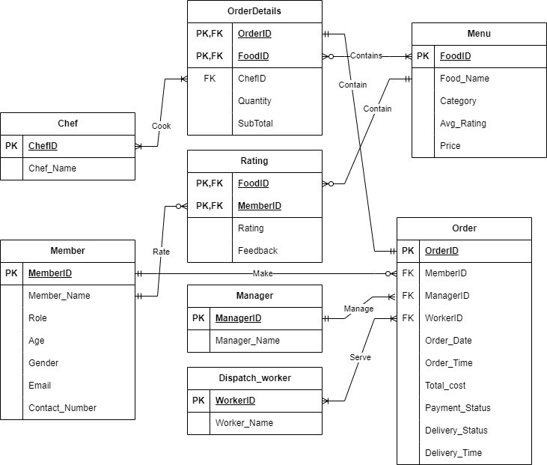

Composite primary key-foreign key is used in table “OrderDetails” and table “Rating” instead of surrogate key to fulfil the requirement of the business rules and maintain the relationships between the tables.

A composite PKFK in table “OrderDetails” is to uniquely identify each order detail to the corresponding order and food items. While a composite PKFK in table “Rating” is to manage the relationship between members and food items so each food item can only be rated once by different members.

# References

Aberdeen, A. D.-W. (2020). The Active Database Management System Manifesto: A Rulebase of ADBMS Features. *ACM SIGMOD, 25*(3), pp40-49. doi:https://doi.org/10.1145/234889.234896

Bieri, C. (2021). An Overview into the InterPlanetary File System (IPFS): Use Cases, Advantages and Drawbacks. *Communication Systems XIV*, pp78-99. Retrieved from https://files.ifi.uzh.ch/CSG/teaching/FS21/IFI_2021_02.pdf#page=78

Cambridge, D. (2024). Meaning of File System. *Cambridge Dictionary*. Retrieved from https://dictionary.cambridge.org/dictionary/english/file-system

GeeksforGeeks. (2023). Difference between File System and DBMS. *GeeksforGeeks*. Retrieved from https://www.geeksforgeeks.org/difference-between-file-system-and-dbms/

Kim, H. (2021). Use of Mobile Grocery Shopping Application: Motivation and Decision-Making Process among South Korean Consumers. *Journals of Theoretical and Applied Electronic Commerce Research, 16*(7), pp2672-2693. doi:https://doi.org/10.3390/jtaer16070147

Livshits, E., Kochirgan, R., Tsur, S., Ilyas, I. F., Kimelfeld, B., & Roy, S. (2021). Properties of Inconsistency Measures for Databases. *SIGMOD '21: Proceedings of the 2021 International Conference on Management of Data*, pp1182-1194. doi:https://doi.org/10.1145/3448016.3457310

Menewar, H., Bhandari, S., Mahajan, P., & Dange, P. (2023). Smart Canteen and Cafeteria Management System using RFID Technology. *iJRASET, 7*(5), pp1-7. doi:https://doi.org/10.22214/ijraset.2023.51975

Omotunde, H., & Ahmed, M. (2023). A Comprehensive Review of Security Measures in Database Systems: Assessing Authentication, Access Control, and Beyond. *Mesopotamian Journal of CyberSecurity*, pp115-133. doi:https://doi.org/10.58496/MJCSC/2023/016

Singh, A. J. (2022). File System Vs DBMS - What's The Difference? *Scaler Topics*. Retrieved from https://www.scaler.com/topics/file-system-vs-dbms/

Sullivan, E., & O'Brien, E. (2024). File System. *TechTarget*. Retrieved from https://www.techtarget.com/searchstorage/definition/file-system

Wang, F., Wang, H., & Xue, L. (2021). Research on Data Security in Big Data Cloud Computing Environment. *IEEE Xplore*. doi:https://doi.org/10.1109/IAEAC50856.2021.9391025